**The Online Book Store**

**Abstract:-**

Nowadays, the network plays an import role in people’s life. In the process of the improvement of the people’s living standard, people’s demands of the life’s quality and efficiency is more higher, the traditional bookstore’s inconvenience gradually emerge, and the online bookstore has gradually be used in public. The online bookstore is a revolution of book industry. The traditional bookstores’ operation time, address and space is limited, so the types of books and books to find received a degree of restriction. But the online bookstore broke the management mode of traditional bookstore, as long as you have a computer, you can buy the book anywhere, saving time and effort, shortening the time of book selection link effectively. The online bookstore system based on the principle of provides convenience and service to people.

**1.Introduction**

1.1 **Research Background** :- The Internet has been favored by more and more people for its high efficiency and richness, and e-commerce has emerged. The online bookstore is a form of e-commerce and book sales industry in one form, it has many advantages, such as: Bookstore size is relatively small, cost savings; transaction activities can be anytime, anywhere, improve service efficiency, The information is complete, more convenient retrieval, the new book information on the new, consumers can see in a timely manner, trading activities can be launched immediately, so online bookstore in today's era of development is extremely rapid. Online bookstore system is the main function of the trading platform for the site, consumers can connect to the Internet through the computer into the online bookstore and then check the book information, if you need to purchase should be registered landing, select their own books, submit orders and pay Operation to complete the entire book ordering process, to achieve online transactions.

1.2 **The Purpose and Significance of The Project**:- With the online bookstore system, consumers do not need to blindly go to various places to find their own books, but only in a computer connected to the Internet log on online bookstore system, in the search box, type you want to find Of the book information retrieval, you can efficiently know whether the site has its own books, if you can online direct purchase, if not, you can change the home bookstore to continue to search or provide advice to the seller in order to supply, This greatly facilitates every consumer, saving time and labour. The online bookstore system can not only reduce costs, save time, space, to bring convenience to everyone, but also to promote the development of the logistics industry, serve three purposes, mutual benefit. More importantly, in today's world, the increasingly close ties between countries, more frequent exchanges, the economy tends to globalization, which promote the future development of online bookstore system has some practical significance.

**2. Demand analysis**

2.1 **Analysis of Current Situation**:- The development of online bookstores in China has gone through four stages: the embryonic stage, the development stage, the mature stage, and the prosperous stage. In recent years, the types of online bookstores are varied, including online bookstore, book sales online bookstore, information service online bookstore, etc. At the same time, online bookstore business model also has a variety of situations: BTOB mode, BTOC mode, BBC mode.

2.2 **System User Analysis**:-The online bookstore's main users are divided into two categories, one is the front user, one is the background user. Front-end users are mainly customers who consume online bookstores. Front-end users can register, login, query, join shopping cart, place orders, submit orders, modify personal information, confirm receipt and add comments on the website. And add, modify or delete the book classification; add, modify or delete the book information, manage the order information and reply to the user's comments. The user is the administrator, the administrator to play the role of overall planning, master and control the front information and so on.

2.3 **System function analysis:-** The online bookstore is opened in the network, not a physical store but a virtual store. In order to improve the efficiency of the query, the site can not only use a single condition query, but also can use multiple conditions to achieve accurate query, the query will be added after the shopping cart function, the query function, And then you can purchase to submit orders, generate orders and payment to complete the entire purchase process function, the user can submit orders before the order to modify, when the seller after the shipment can also confirm the receipt of the operation to complete the transaction , After the completion of the transaction the user can comment on the corresponding book, the other unregistered users can not purchase books or add to the shopping cart operation, the user must first register as a member of the bookstore, log in before the above operations. In addition to the foreground function, the need for background management, administrators can log in through the corresponding Web site background, after the classification of the book catalog and book information to add, modify and delete, but also the order information management, Such as the cancellation of unpaid or unpaid orders, the payment of orders for delivery operations, etc., can also reply to the user's comments, you can reply to each comment, and the client's book details page is displayed.

3.**Proposed System**

In the Previous System, Details are Stored Manually in papers, to share the

details between employees was a Financial drawback. Updations in the

details is a tedious task.

But a new system was proposed to overcome the above drawbacks.

Functionalities and advantages of proposed system are:

* Data is Centralized which has overcome the Sharing problem in

previous system.

* As data is Maintained electronically, it’s easy for a person to update

the details, which has overcome the tedious updation in previous

system.

* Maintenance is easy and performance is good.
* Mainly the system has automated the Transportation Process.

**3.1 Benefits of the Proposed System**

* The working in the organization will be well planned and organized.

The data will be stored properly in data stores, which will help in

retrieval of Information as well as its storage.

* The level of accuracy in the proposed system will be higher. All

operation would be done correctly and it ensures that whatever

information is coming from the center is accurate.

➢ The reliability of the proposed system will be high due to the above

stated reasons. The reason for the increased reliability of the system is

that now there would be proper storage and access to information.

➢ In the proposed system utmost care would be that no information is

repeated anywhere, in storage or otherwise. This would assure

economic use of storage space and consistency in the data stored.

**4. Software and Hardware Requirements:-**

**4.1 Hardware Requirements:-**

Processor : Intel Pentium 4

RAM : 512 MB RAM

Monitor : 1 5”Colour Monitor

Processor Speed : 1.7 GHZ

Hard disk : 1.44 MB FDD

CD Drive : 52- X CD ROM

**4.2 Software Requirements:-**

Notepad + +

Xampp server

MySql as Database.

P.H.P language as backend.

**5.DF Daigram**

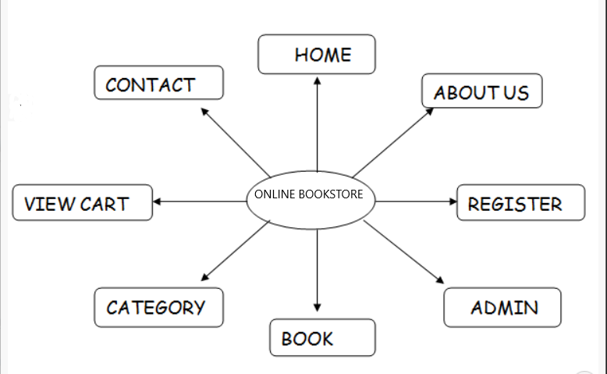

**6.ER Daigram**

Product id product image

Category

Order

Product

Visitor

Order Items Details

Customer

**SCREENSHOTS**

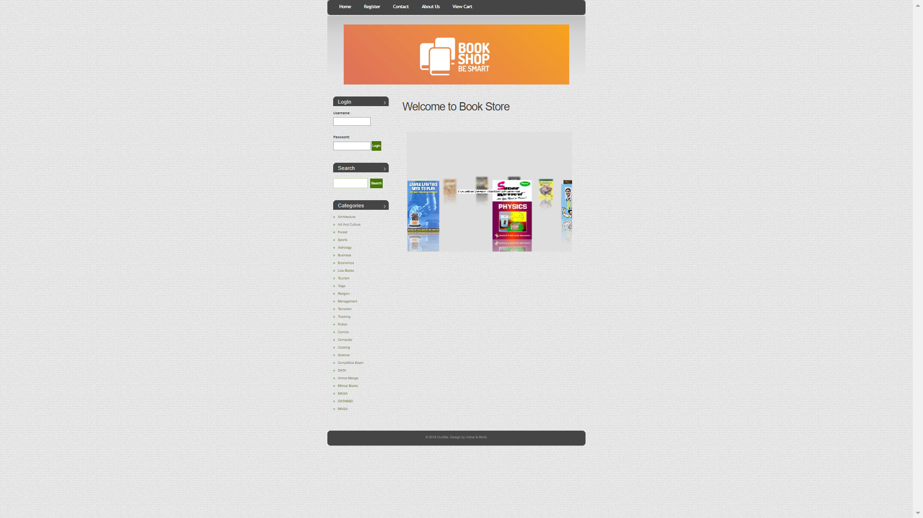

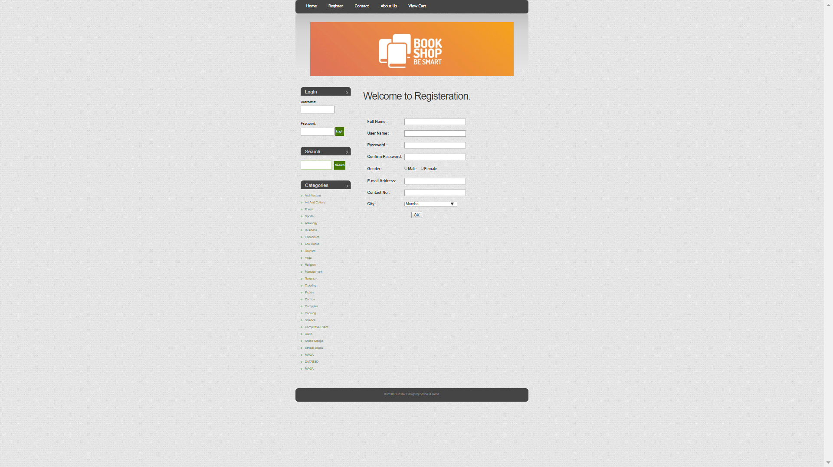

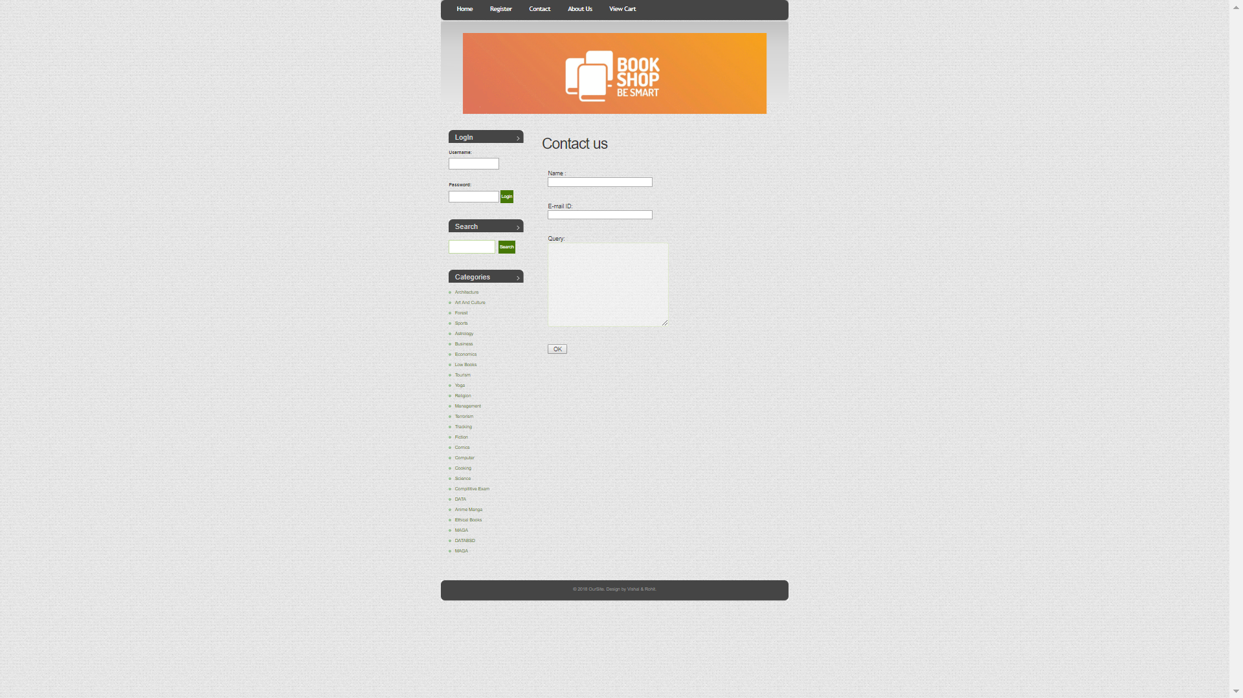

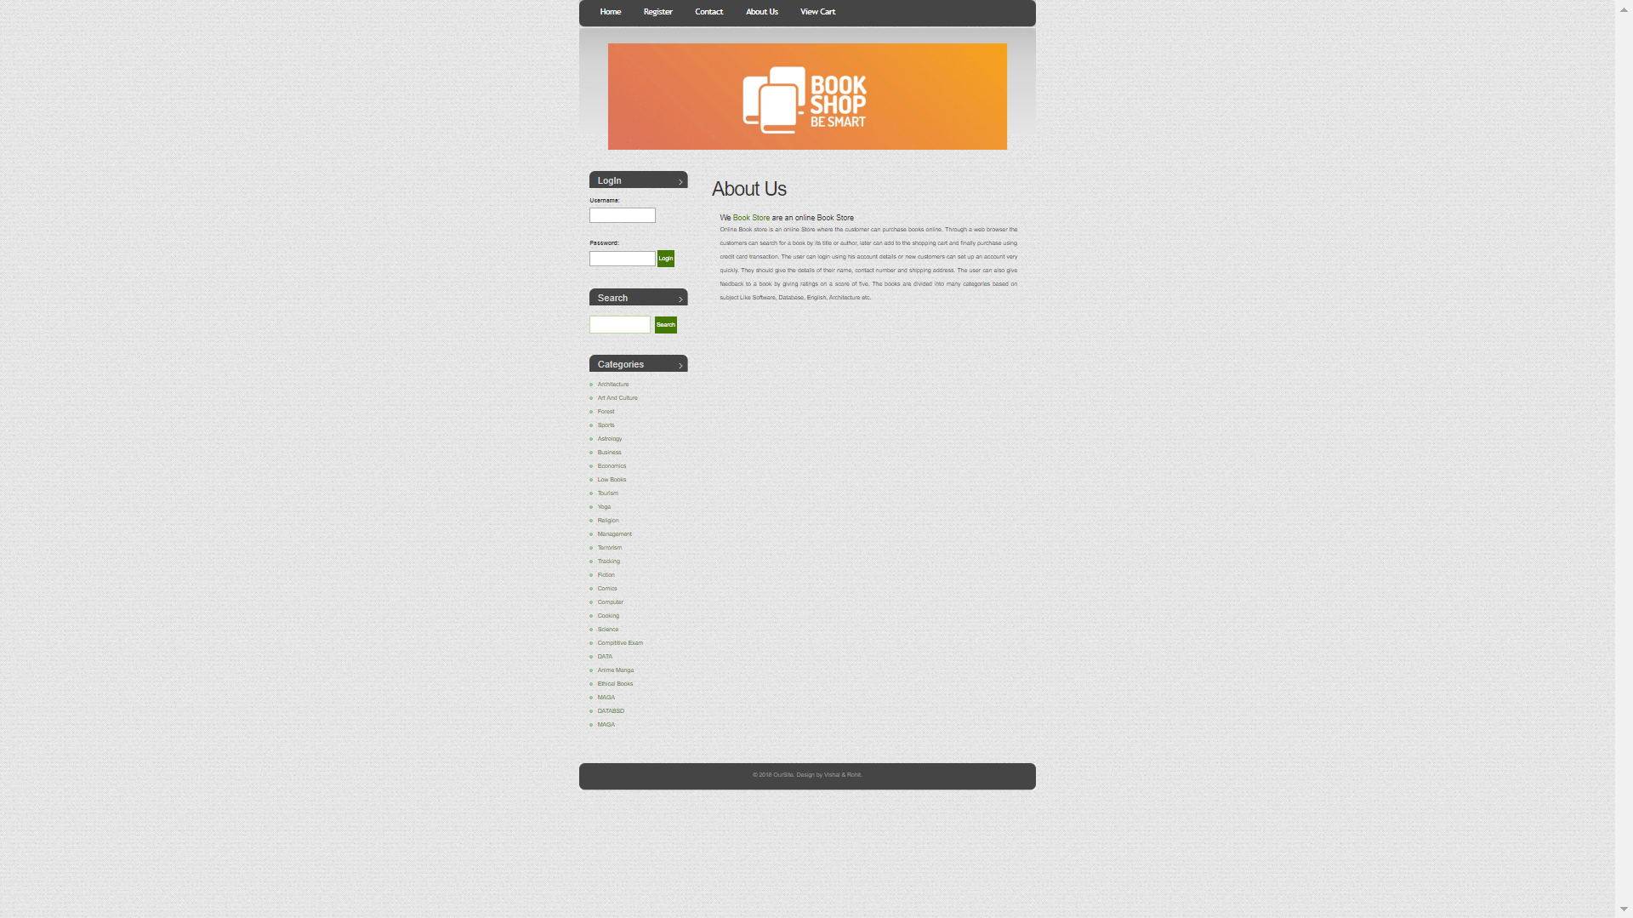

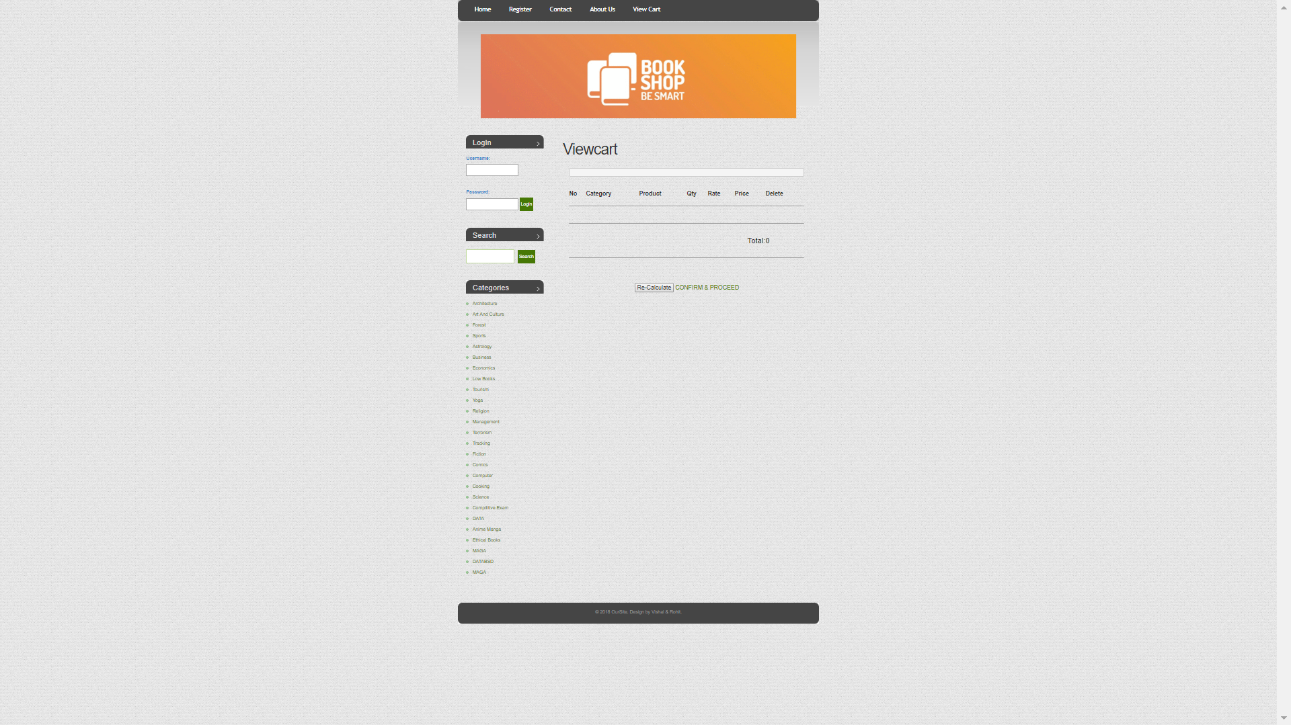

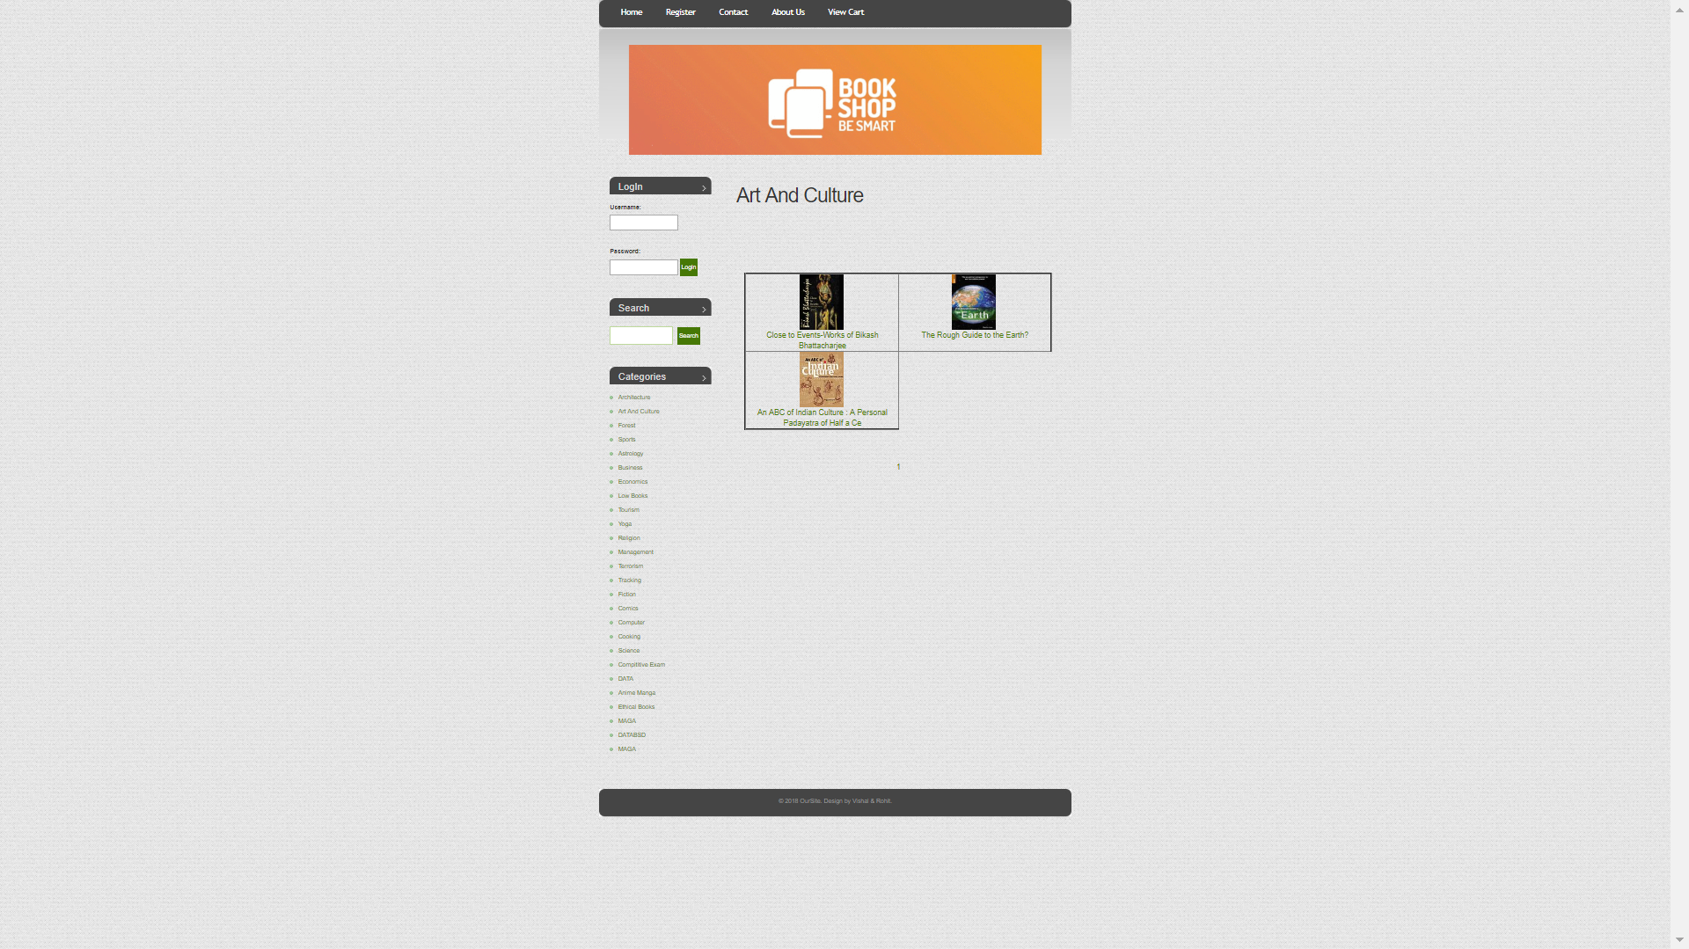

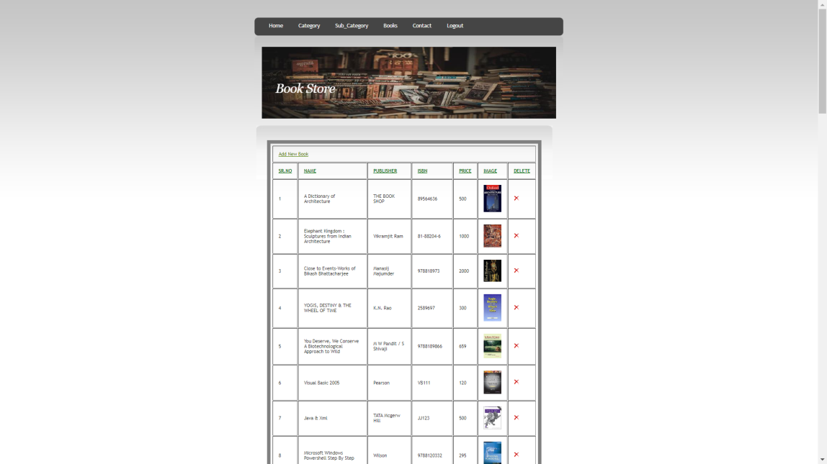

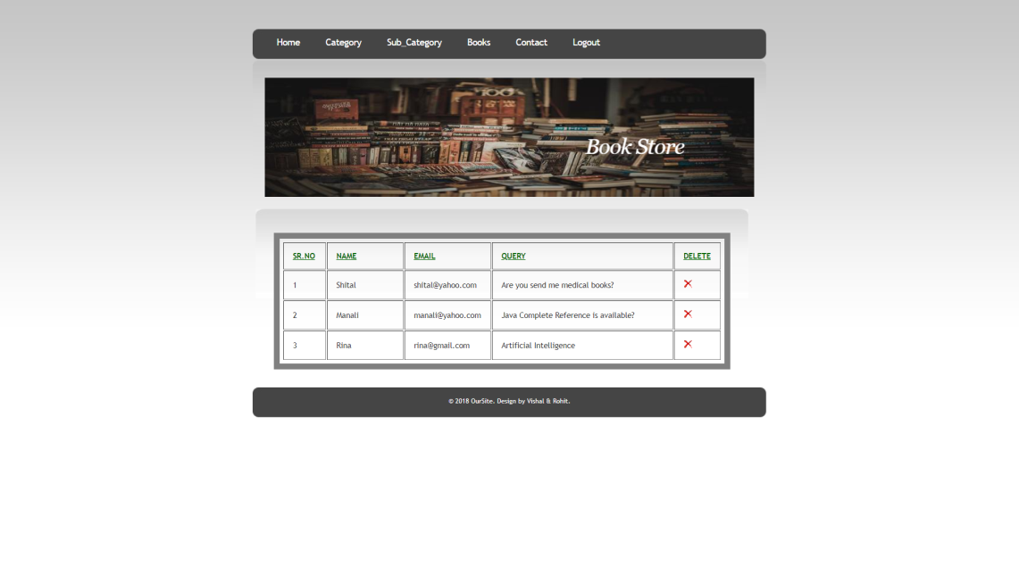

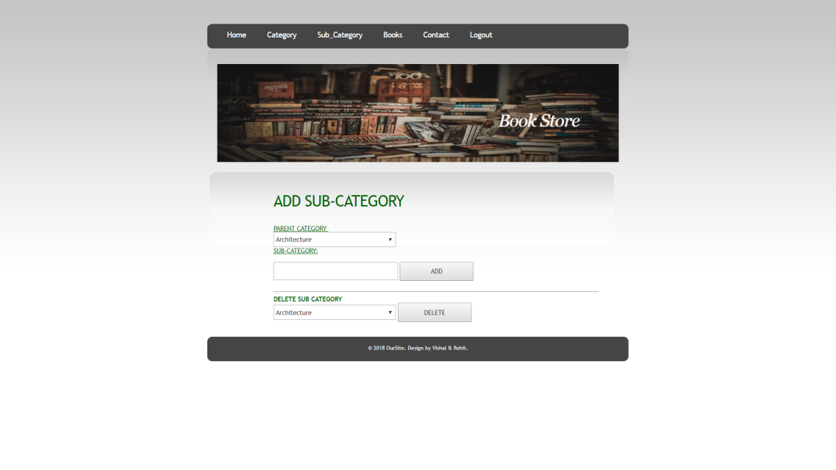

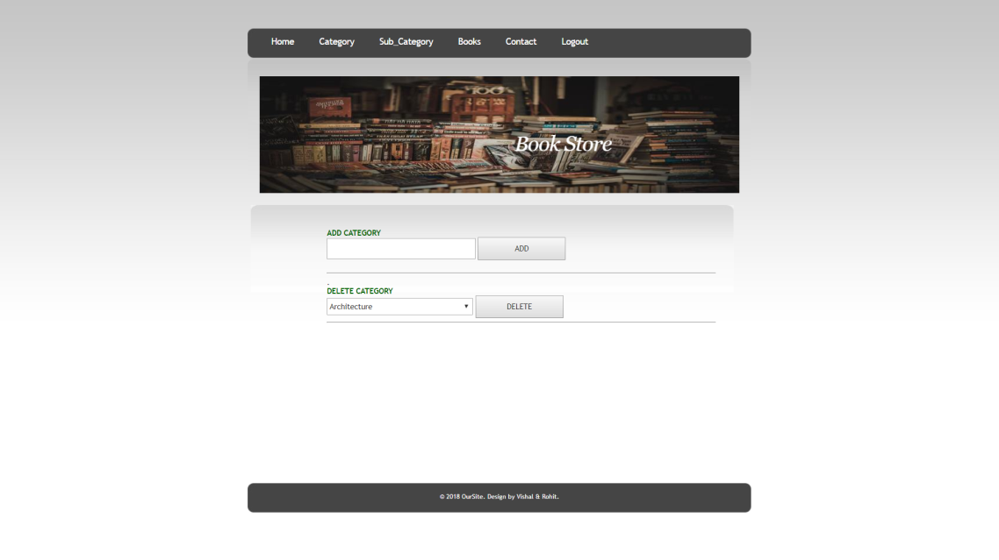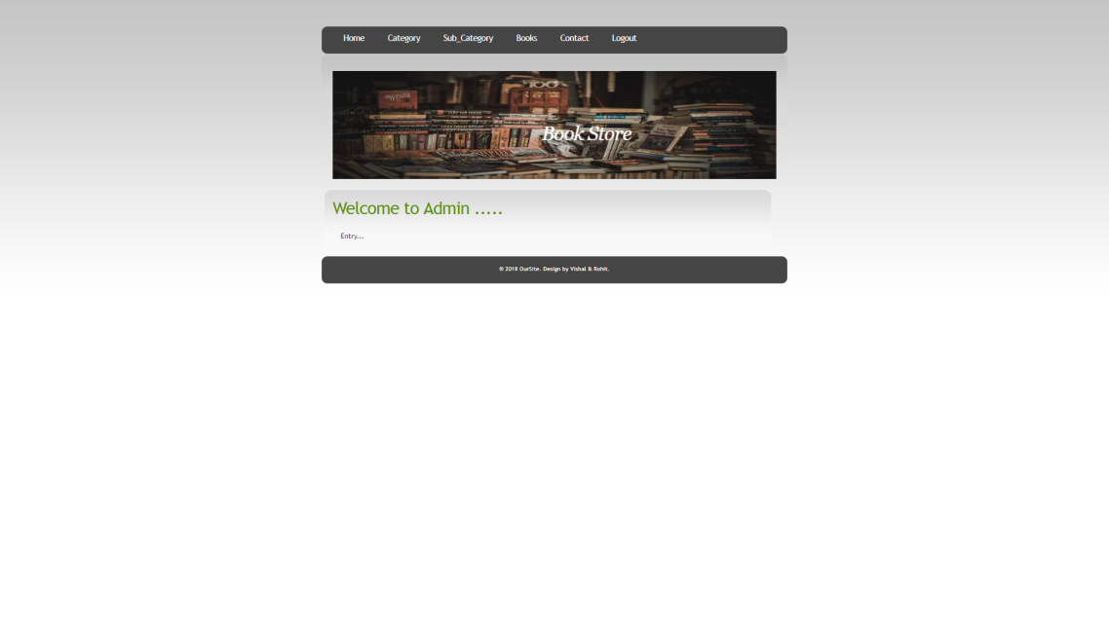

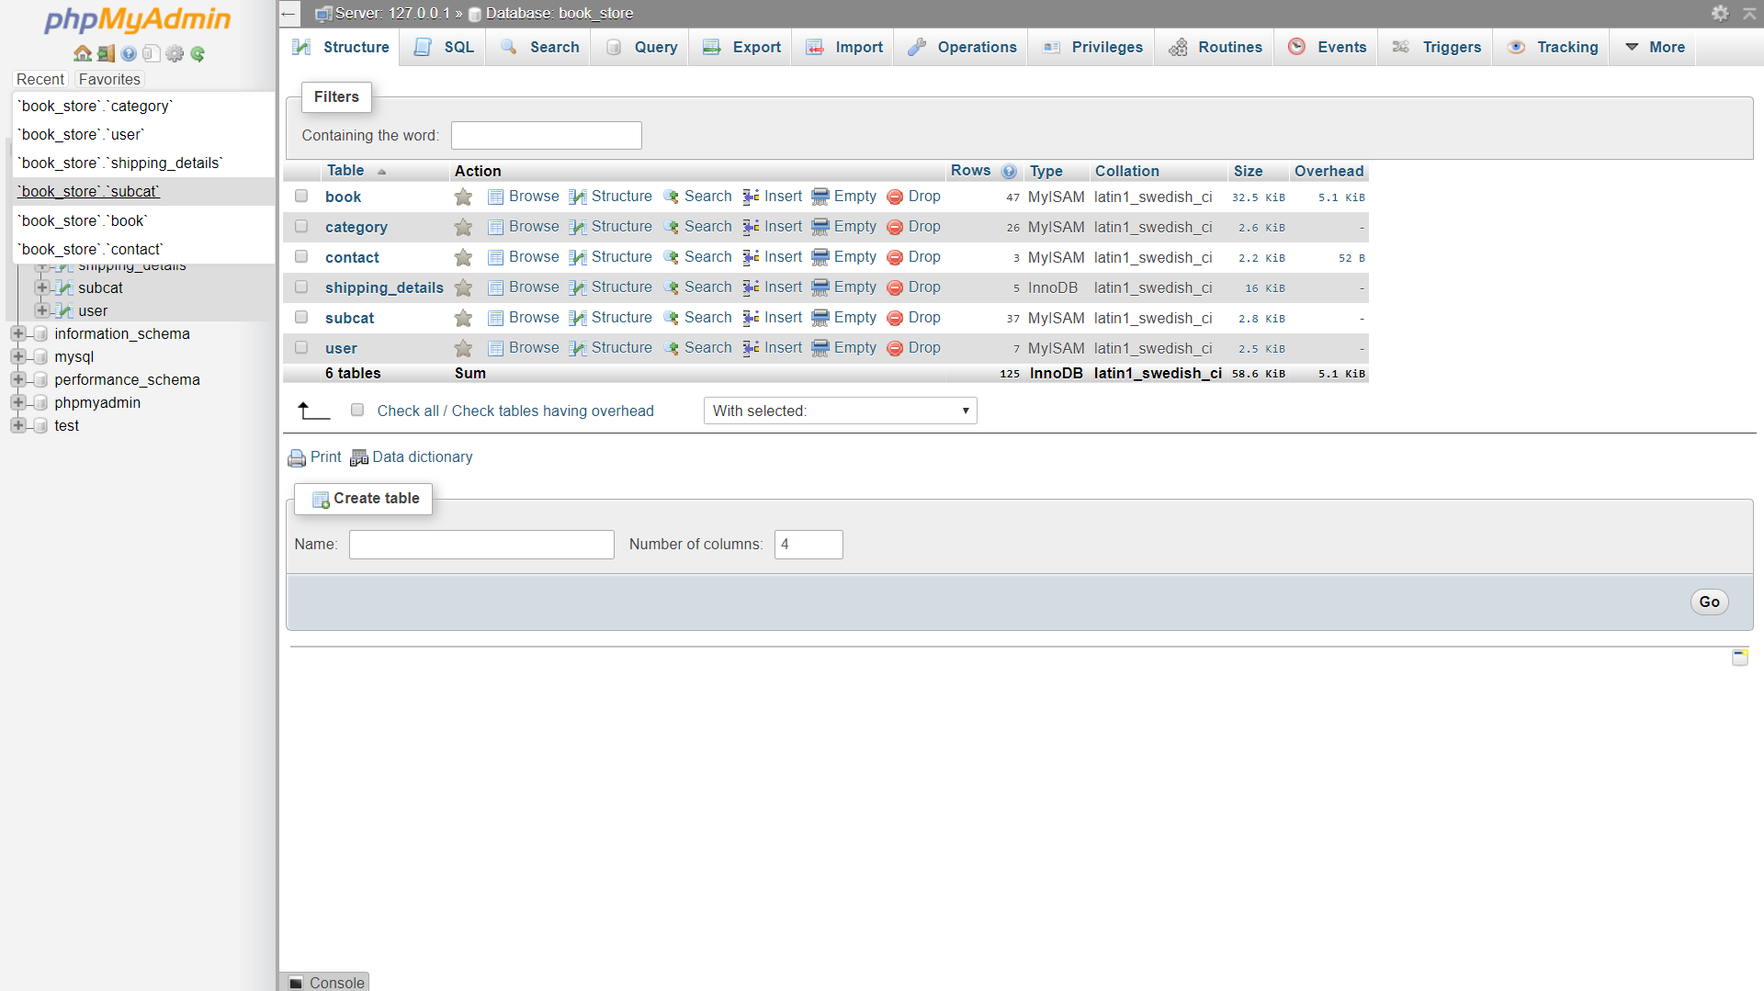

**BIBLIOGRAPHY**

**W3SCHOOL.COM**

**TUTORIALPOINT.COM**

**PROGRAMMINGGEEKS.COM**